Data Cleaning, Transformation and Modelling
- Assignment
Theoretical Questions -
Question 1: What is Data Loading in Power BI and why is it considered the first step of analysis?
Data Loading is the process of connecting Power BI to a data source (like an Excel file, SQL database, or web URL) and bringing that data into the Power BI environment.
• It is the first step because analysis cannot begin without a foundation.
• It defines the scope of your project by determining which fields and records are available for visualization.
Question 2: Explain the difference between "Load" and "Transform Data" in Power BI.
• Load: This option imports the data exactly as it is in the source file directly into the Power BI data model. Use this only if your data is already "clean" and perfectly formatted.
• Transform Data: This opens the Power Query Editor. It allows you to clean, filter, and reshape your data (e.g., removing nulls, changing data types, or merging columns) before it enters the model.
Question 3: What is a Fact Table and a Dimension Table?
• Fact Table: Contains quantitative data (numbers/metrics) that can be summed or averaged, usually with a high volume of rows.
• Example from Dataset: The main table containing daily counts of Confirmed Cases, Deaths, and Recovered Cases.
• Dimension Table: Contains descriptive attributes (text) used to filter and group the facts.
• Example from Dataset: A separate table for Country/Region details or a Date Table.
Question 4: Why is Star Schema preferred over Snowflake Schema in Power BI?
The Star Schema is preferred because it is simpler and faster.
• It involves fewer "joins" (relationships) between tables, which improves report performance.
• Power BI is optimized for this layout, making it easier for the engine to calculate DAX measures quickly.
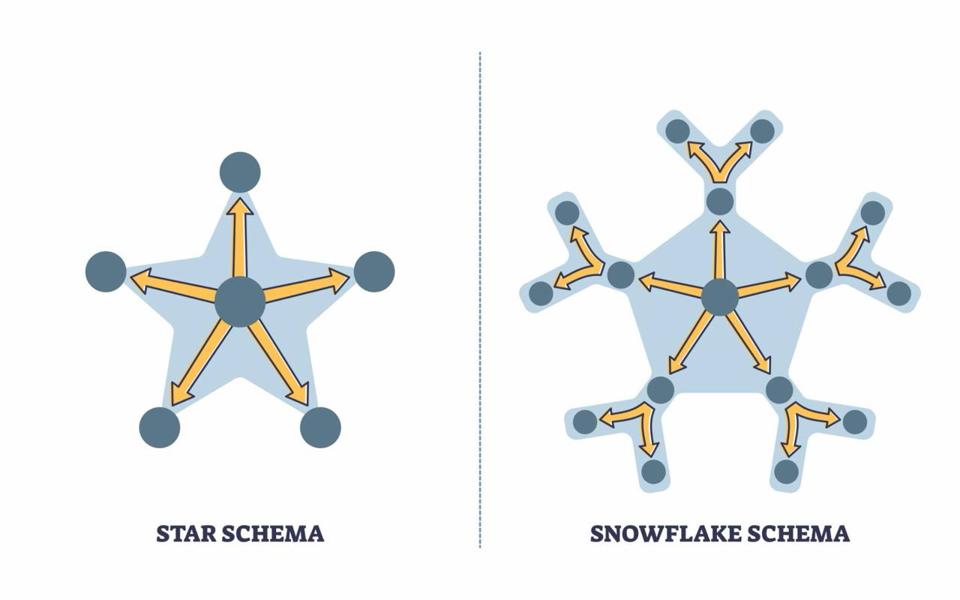
Practical Questions -
These steps are performed within the Power Query Editor (Transform Data).
Question 5: Identify and remove duplicate records.
1. Select the Date, Country, and State columns (hold Ctrl to select multiple).
2. Right-click on one of the column headers.
3. Select Remove Duplicates.
Question 6: Identify and replace null values in Vaccination_Status.
1. Right-click the Vaccination_Status column.
2. Select Replace Values....
3. In "Value To Find," leave it blank or type null.
4. In "Replace With," type a placeholder like "Unknown" or "Not Reported".
Question 7: Create a new column to calculate Recovery Rate.
1.Go to the Add Column tab and select Custom Column.
2.Name the column Recovery Rate.

3.Use the following formula:

4.After clicking OK, change the data type of the new column to Percentage.
Question 8: Create a summarized table showing total confirmed cases by Country.
1. Go to the Transform tab and click Group By.
2. Select Country as the column to group by.
3. Name the new column Total Confirmed.
4. Set the Operation to Sum and the Column to Confirmed.
Would you like me to generate a DAX formula for any specific COVID-19 trend analysis, such as a rolling 7-day average of cases?

